COLLEGE ADMISSION CHATBOT
1. Introduction
The College Admission Chatbot is a simple AI-based application developed to assist students with common admission-related queries. Instead of repeatedly contacting the admission office, students can interact with the chatbot and receive instant information about courses, eligibility, fees, application procedures, required documents, scholarships, hostel facilities, and other admission-related services. The application provides a simple and user-friendly interface where students can enter their questions and receive relevant responses.
2. Problem Statement
Students often have difficulty obtaining quick information about the admission process. Common questions regarding courses, eligibility, fees, documents, and application procedures are repeatedly asked to the admission office. This increases the workload of staff and may cause delays in providing information. To address this problem, a chatbot can provide immediate responses to frequently asked admission queries.
3. Objective
The main objective of this project is to develop a user-friendly chatbot that can:
- Answer frequently asked admission queries.
- Provide information about courses and eligibility.
- Explain the application procedure.
- Provide details about fees and required documents.
- Provide information about scholarships and campus facilities.
- Handle questions for which information is not available.
4. Proposed System
The proposed system uses a keyword-based question-answer mechanism. When a student enters a question, the application checks the question for relevant keywords and identifies the corresponding information. The chatbot then displays the appropriate response. If the entered question does not match the available information, the system displays a fallback response asking the student to contact the admission office.
5. Technologies Used
Python is used for developing the chatbot logic. Streamlit is used to create the web-based user interface, and Visual Studio Code is used as the development environment.
6. System Workflow
Student enters a question
↓
The chatbot analyses the question
↓
Relevant keyword is identified
↓
Matching information is retrieved
↓
Answer is displayed to the student
↓
If no match is found, a fallback response is displayed
7. Main Features
- Course information
- Eligibility information
- Fee information
- Admission procedure
- Required document details
- Scholarship information
- Hostel information
- Transport information
- Contact information
- Fallback response for unsupported queries
- Where is the college located?
- When does the admission process start?
- How can I contact the admission office?
- What facilities are available in the college?
- What is the last date for application?
- How can I submit the application?
10. Fallback Handling
When the chatbot receives a question outside its available knowledge, it provides a suitable response instead of generating unrelated information.
Example:
"Sorry, I don't have information about this query. Please contact the college admission office for further assistance."
12. Limitations
The current system can answer only questions related to the information provided in its knowledge base. It may not understand highly complex or completely unrelated questions. The information must also be updated regularly to reflect changes in admission rules, fees, and schedules.
13. Future Enhancements
The chatbot can be enhanced by integrating Generative AI, voice interaction, multilingual support, a live college database, and mobile application support. These improvements can make the system more intelligent and useful for students.
14. Conclusion
The College Admission Chatbot provides a simple and effective solution for handling common admission-related queries. It demonstrates how conversational AI can be used in the education sector to provide quick access to information and improve the student admission experience. The proposed system can be further developed into a more intelligent and multilingual admission assistance platform.
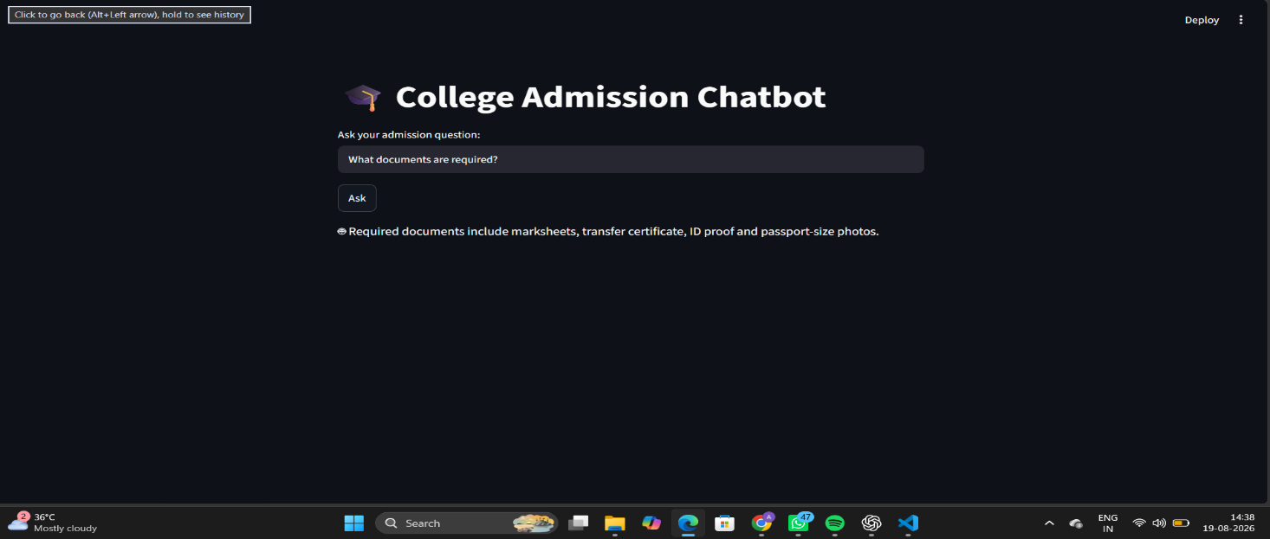

1. STUDENT NOTES SUMMARIZER
1. Introduction
The Student Notes Summarizer is an AI-based application designed to help students quickly understand lengthy study materials. The application accepts notes as input and identifies the most important sentences to generate a concise summary. This helps students save time and focus on the key concepts while preparing for examinations.
2. Problem Statement
Students often need to study large amounts of notes before examinations. Reading lengthy materials repeatedly can be time-consuming and make it difficult to identify the most important information.
The proposed system provides a simple solution by automatically identifying important sentences from the given notes and presenting them as a short summary.
3. Objective
The main objective of this project is to develop a simple and user-friendly application that can:
- Accept lengthy study notes as input.
- Identify important information from the notes.
- Generate a concise summary.
- Help students revise topics quickly.
- Reduce the time required to read lengthy study materials.
4. Proposed System
The proposed system uses an extractive summarization approach. The application analyses the words and sentences in the input notes and identifies frequently occurring important words. Sentences containing more important words are given higher priority and selected for the final summary.
The generated summary is then displayed through a simple web interface.
5. Technologies Used
Python is used for implementing the summarization logic. Streamlit is used to create the interactive web interface, and Visual Studio Code is used as the development environment.
6. System Workflow
Student enters study notes
↓
The application analyses the input text
↓
Important words are identified
↓
Sentences are scored based on important words
↓
The most relevant sentences are selected
↓
A concise summary is displayed

7. Main Features
- Simple and user-friendly interface
- Text input for lengthy study notes
- Automatic identification of important information
- Generation of concise summaries
- Easy-to-read output
- Suitable for examination revision
- Empty-input handling
8. Advantages
The application reduces the time required to read lengthy notes and helps students identify important concepts quickly. It provides a simple interface and can be used for different academic subjects. The generated summary is also useful for quick examination revision.
9. Limitations
The current system uses an extractive approach and selects important sentences from the original notes. Therefore, it may not generate completely new sentences or understand the deeper meaning of complex topics. The quality of the summary depends on the quality and structure of the input text.
10. Future Enhancements
The application can be improved by integrating advanced Generative AI models for abstractive summarization. Additional features such as PDF upload, summary length selection, keyword extraction, multilingual summarization, and downloadable summaries can also be added.
11. Conclusion
The Student Notes Summarizer provides a simple and effective solution for converting lengthy study materials into concise revision content. By identifying important information from the input notes, the application helps students save time and concentrate on key concepts. The system can be further enhanced with advanced AI techniques and additional document-processing features.

